Health Announcements K-5 2019

January – Exercise and Learning

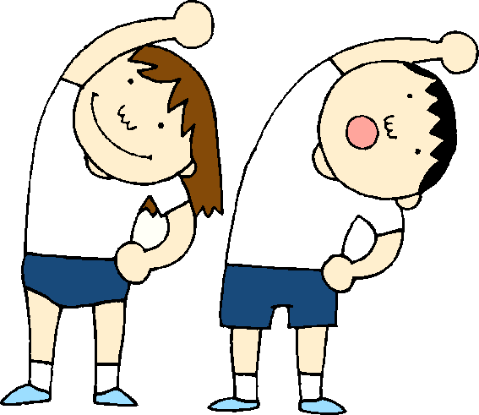

- Exercise is good for your brain. It helps you feel good about yourself, learn and remember. Just 10 minutes of active playing can make you smarter!

- A little exercise is good, but more is better. Try to exercise for at least one hour everyday!

- Exercise is fun in the winter! You can go for a walk in the snow, make a snowman, snow fort or snow angel, go sledding, skating or skiing. Exercising in the fresh air is healthy for you.

- Did you know there are a lot of ways to exercise inside your home? If the weather isn’t nice outside, you can dance, do yoga, stretch, build a blanket fort or play a game like “Twister.”

- Exercise is good for your body. It helps your muscles and bones grow and get stronger. Make sure you exercise for one hour everyday for a healthy, strong body.

